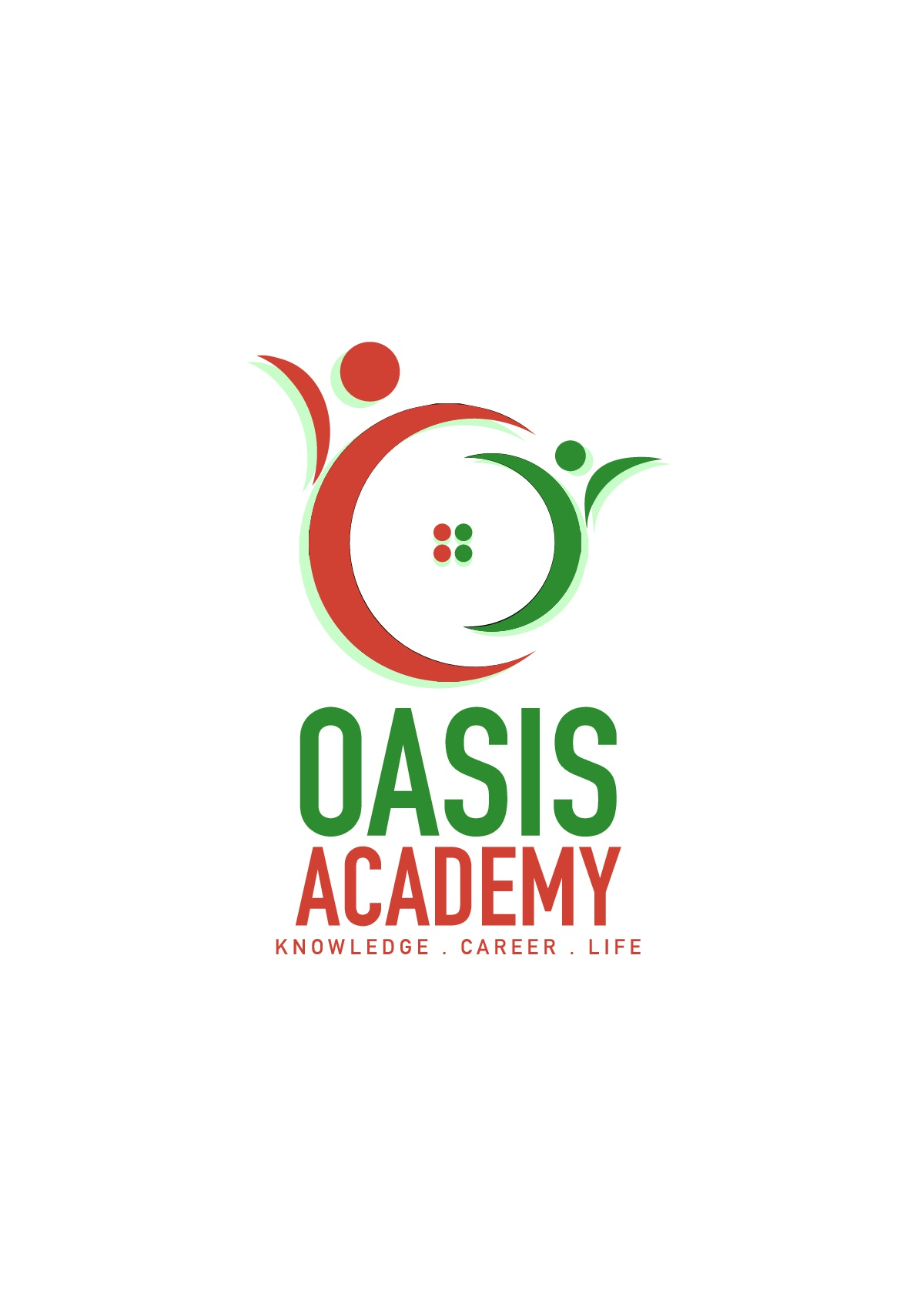

Name: Wong Ben Kim

Login ID: wongbenkim@oasis.portal.my

Course title: Essential of Marketing and Customer Service

Subject Code: BHM02

Submitted date: 17 July 2017

**Table of Contents**

|  |  |  |
| --- | --- | --- |
| **No** | **Details** | **Page** |
| 1 | Executive Summary | 2 |
| 2 | Introduction | 3-4 |
| 3 | Assignment Question |  |
|  | Question 1 | 5-8 |
|  | Question 2 | 9-13 |
|  | Question 3 | 14-16 |
|  | Question 4 | 17-19 |
| 4 | Conclusion | 20-21 |
| 5 | References | 22-24 |
|  | Appendix | - |

**Executive Summary**

In this assignment, I will explain what I learn in the hospitality marketing and customer service in hospitality management. The hospitality marketing was play a vital role in the hospitality management. This is because the marketing is a process to attract the customers to spend the money for the company by selling some products and some great service attitude to let the company’s goal can be successful. First, I learn about the marketing in hospitality and the important of Hospitality Marketing. Besides, I had studied about the difference between Marketing and Customer Service. Then, I have covered on the characters of marketing and customer service. Furthermore, I also understand about the Marketing strategies in Hospitality Management. Moreover, I had to define the customer service skill and characteristics. Lastly, I had to know about the importance of hospitality customer service. I will explain all I understood in this assignment in the introduction.

**Introduction**

I will explain what I learn and understood about the Hospitality Marketing and customer service in this assignment. Marketing and customer service in hospitality are an importance step towards the company’s goals. This is due to the reason that, Hospitality marketing and customer service is a process to meet the needs of guests. When the guests are satisfied with our products and service will be able to attract more consumers. We can also calling that is a planning to plan how to promote the business and product to attract more consumers. Thus our product must be quality and have a fair price. We can also use the social media to let more people know us. Then the customer will visit us. The best product to attract the customer is customer service and we also can earn money in customer service. This is because, our service staff will explain to them about our product and give a great service to them. So, they will feel happy in our service and they will buy our product and pay the service charge. Thus, what is the good customer service? The most important thing in customer service is smile because when you smile the customer will feel friendly and they will smile to you. Even you do something wrong to them when you apologize to them with smile. They probably will forgive you. Thus, smile can bring a lot of positive energy to customer. We also can plan to sell the product in right place. For example, we can sell our product in good environment and the place where the customer like. We also can plan some promotion or discount to customer. Thus, customer will be willing to buy our product in cheaper. For example, we can give 20% discount to them or buy one free one. All the customer like to buy a product will promotion. We must also have a good relationship with other business because we can cooperation with them. A business need to plan how to attract the customer to pay money to them. If a business have plan like this they will be successfully.

**Assignment Questions**

**Question 1**

Briefly explain about Marketing in Hospitality and the Importance of Hospitality Marketing.

In any business, a strong showcasing procedure is basic to building a brand, drawing in new clients and looking after dedication. The cordiality business is the same. Since client reliability is vital, promoting administrators and officials commit a ton of time and assets to building brand mindfulness and making continuous, interconnected crusades. These showcasing endeavors normally incorporate both print and computerized insurance that objective previous visitors while likewise pulling in new customers. In any case, this specific industry has an interesting arrangement of difficulties that must be overcome. Understanding the significance of promoting in the accommodation business can enable you to excel and emerge in the aggressive employment advertise.

Cordiality deals are not quite the same as buyer merchandise deals since advertisers must offer substantial and in addition immaterial items. Much of the time this implies they are showcasing administrations as opposed to products, and achievement depends on making the correct feeling in the purchaser. For instance, a resort will need to develop an unwinding, fun air that is unmistakable to clients and rouses those same emotions in the consumer. Because the cordiality business is for the most part comprised of tourism and other experiential administrations, a reliable brand character is additionally critical. Advertisers need to guarantee that brand acknowledgment exists with the goal that clients will utilize their administrations over and over. Rehash clients acquire a sizeable segment of income, so showcasing methodology must be part between keeping up associations with past clients while searching out new ones.

Organizations in the accommodation business utilize different techniques to create and keep up a viable promoting plan. The accompanying are a portion of the general systems that advertisers use for mark achievement. Clients pick inns and other neighborliness administrations for an assortment of reasons. From area to offices and advantages, organizations must make sure that they're giving what purchasers are looking to. The part of advertisers is to recognize what factors make clients pick a specific accommodation administration, and this requires broad research. By addressing present and previous visitors, observing client audits on sites, exploring industry information and that's just the beginning, advertising experts realize what makes an accommodation benefit emerge, and additionally how it can be made strides.

In the event that potential clients don't think about an administration, they can't buy it. That is the place mark mindfulness comes in. Advertisers ensure data on inns, resorts and eateries is anything but difficult to discover and up and coming. They can do this by purchasing advertisement space on applicable travel destinations, making a drawing in site and working together with other, noncompeting cordiality benefits in a similar market.

Another shrewd technique for pulling in clients is to run advancements amid specific circumstances of the year, for the most part when business is slower. Presenting motivating forces and offering motivators are recently a portion of the ways that showcasing experts accomplish this. Have you obtained a Groupon for a spa end of the week? That is advancement at work.

To guarantee elevated amounts of rehash business, great client connections are imperative. Not exclusively do rehash clients ordinarily advance an administration through verbal exchange and online networking, however they additionally make a steady income base. One approach to manufacture connections is through client reliability programs, which remunerate clients who routinely utilize a specific friendliness benefit.

**Question 2**

Explain the difference between Marketing VS Customer Service.

Explain the Ethics of Marketing and Customer Service.

The client benefit and the advertising bureaus of an organization are normally two unmistakable and altogether different offices. Notwithstanding, shrewd organizations are understanding that these days of web-based social networking and online surveys that client administration and promoting go as an inseparable unit. It is imperative for associations to change the approaches of old and have promoting and client benefit cooperate, as every division can make the other's employment less demanding and accomplish objectives quicker. When showcasing and client benefit groups cooperate, it understands one of the well established issues of client benefit being unconscious of the unique advancements that the promoting group publicizes. In the meantime it additionally takes care of another issue that happens today, when poor client benefit brings about an issue for the online networking promoting division of the office. Today, we will examine some client benefit strategies and strategies that will keep clients and customers upbeat, so negative online surveys or web-based social networking remarks don't turn into an issue for the promoting division. The showcasing morals are partitioned in 5 which are Relationship Advertising, Value-based Promoting, Shortage Advertising, Invitation to take action (CTA) Showcasing and Informal Showcasing

Relationship Showcasing. Many organizations concentrate on building associations with their clients rather than constantly selective attempting to offer them something (value-based advertising). Clients who adore your image more will likewise go through more cash with your image. Numerous customary retailers have observed this to be valid. Walgreens has seen that clients who purchase from the greater part of their acquiring channels (store, web, portable, and so forth) purchase up to six times more than the normal client that exclusive purchases in their store.

Value-based Advertising. Driving deals can be testing, particularly for retailers that need to reliably pitch items in high volume to purchasers. Keeping in mind the end goal to remain with the requests of financial specialists, retailers need to urge purchasers to purchase utilizing coupons, rebates, liquidations, and deals occasions. High volume enormous box retailers like Target are always running special occasions keeping in mind the end goal to get intrigued purchasers into their stores.

Shortage Promoting. In a few markets it's critical to control how much item is accessible at one time. By and large this is done in light of the trouble of getting crude materials or higher nature of the item. An organization may make their items open to just a couple of clients. Moves Royce's arrival of their Chinese editioncar called Ghost sold rapidly. While the cost of the auto was higher than most autos the shortage drove the longing and the cost.

Verbal Showcasing. Verbal Showcasing is the death of data from individual to individual by oral correspondence. Clients are exceptionally eager to impart to the world the brands they cherish. Numerous shoppers discover significance in sharing stories of their most loved items and administrations. Informal exchange is one of the antiquated ways individuals found out about what to buy. Current advertisers have figured out how to make bona fide verbal exchange for their organizations and the items they speak to.

Suggestion to take action (CTA) Showcasing. CTA Promoting alludes to techniques for changing over web activity into leads or deals on sites utilizing content, illustrations, or different components of website composition. Transformation systems help enhance the rate of online guests who progress toward becoming clients or who join the mailing list.

Hence, the morals of client benefit are Relator, Communicator, Devotee, Practitioner and Coordinator.

Relator. The Relator is worried about every individual's needs and intrigue and identifies with every individual's perspective. There is a solid need to make the client can rest easy. Also, the Relator has a tendency to invest excessively time and vitality with individuals who make them can rest easy.

Communicator. The Communicator feels an individual commitment to help every client, and needs to make them feel great. The Communicator tends to concentrate on distinguishing and taking care of issues and likes to exhibit and grandstand how benefit is expert. There is a propensity to make the adjusting exercises fit the one of a kind needs of the client.

Devotee. The Devotee feels a commitment to teach and persuade the client in the power and capacity of administration. The Devotee is touchy to the necessities and interests of the client, yet may disregard them in the energy to exhibit worth. There is an inclination to postpone adjusting exercises on the off chance that he/she presumes that the client does not comprehend the final product.

Practitioner. The Practitioner focuses on completing things and to getting things going. He/she concentrates on taking care of the client's issues. The Practitioner may ignore protests, expect agree and move to client's adjusting ventures before the client is prepared.

Coordinator. The Coordinator concentrates on instruction and rationale, and shows the consistent decision that the administration will offer. He/she has a tendency to expect that the client's needs and interests are reflected in their answers. Coordinators may end up noticeably eager and basic if the client is not persuaded by their clarification.

**Question 3**

Describe about Marketing strategies and how you can apply your studies in Hospitality Management.

It requires a ton of investment and push to create and keep up an advertising effort that resounds with your target group. As a key mastermind, be that as it may, the improvement of an advertising effort takes much more thought. All things considered, we're continually hunting down approaches to pick up the very essential focused edge. There are times, however, when we as a whole hit the famous divider. In the event that you wind up in that circumstance, at that point you might need to look at these fifteen promoting methodologies that will start your innovative vitality.

Grasp client produced content. As indicated by a study of 839 millennials, they burn through "5.4 hours every day with content made by their associates. This speaks to 30 percent of their aggregate media time and is matched just by all conventional media sorts consolidated (print, radio, and TV, at 33 percent)." In a similar review, "Millennials detailed that UGC is 20 percent more compelling on their buy choices than other media." You can accomplish this by having clients share individual stories trade thoughts and by giving them the instruments to make a promotion for you or through silliness.

Team up with influencers. Another approach to pick up another group of onlookers and expand mark mindfulness is by working together with the best influencers in your industry. Home change store Lowe's permitted "top creators and mother bloggers to assume control over its Instagram represent a couple of days on end." By enabling these influencers to share uplifting content, Lowe's could take advantage of another crowd.

Enable clients to take care of an issue. As superbly expressed on HubSpot, "You're ready to go on the grounds that you give arrangements." A portion of the ways you can enable clients to take care of an issue is by: making how-to-content; offering exclusives that make their lives less demanding; tuning in/reacting to them; or making applications/instruments. You could likewise make a crusade like Orca Chevrolet did in Brazil. The organization collaborated with a neighborhood tow organization and saved stranded drivers by touching base in the new Orca. Not exclusively chevied spare the day, it additionally allowed drivers to test drive the auto.

Give clients a chance to interface. Regardless of the item or administration you're putting forth, your clients need to communicate with your organization, or possibly different clients. AMC, for instance, made an online apparatus that enabled you to Crazy person Yourself. American Express interfaces entrepreneurs to each other and accommodating assets through its OPEN Discussion.

Really begin to tackle Apple. Apple merits uncommon say for the most part since it's an image that has made a whole era of deep rooted advocates. How could they finish this? Keep in mind when the iPod was presented? Macintosh's currently notable procedure included sympathy, center, and credit when they utilized outlines of individuals getting a charge out of the iPod. It might not have been the best MP3 player, but rather it made brand acknowledgment that commanded the market.

**Question 4**

Explain in detail on Customer Service Skills and Characteristics.

Explain the Importance of Hospitality Customer Service.

At the point when most business productions discuss client benefit aptitudes, things like "being an extrovert" tend to take the spotlight. It isn't so much that this characteristic is inside and out wrong, yet it's so dubious and non specific that it is not really an assistance to those hoping to get required in help positions inside an organization, and surely doesn't assist business visionaries/originators who are searching for the correct arrangement of abilities while enlisting the exceedingly vital people will's identity dealing with their clients.

Persistence. On the off chance that you don't see this close to the highest point of a client benefit abilities show, you should simply quit perusing. Not exclusively is persistence imperative to clients, who regularly connect with help when they are confounded and disappointed, but at the same time it's critical to the business everywhere: we've demonstrated you before that awesome administration beats quick administration each and every time. However persistence shouldn't be utilized as a reason for sluggish administration either! Derek Sivers clarified his view on "slower" benefit similar to a connection where the time gone through with the client was utilized to better comprehend their issues and needs from the organization.

Mindfulness. The capacity to truly tune in to clients is so vital for giving extraordinary support of various reasons. A week ago I went over a couple of client input frameworks, and some time before that I demonstrated to you the information on why tuning in to client criticism is an absolute necessity for some organizations who are hoping to develop. In addition to the fact that it is vital to focus on singular client cooperations (viewing the dialect/terms that they use to portray their issues), but at the same time it's vital to be careful and mindful to the criticism that you get on the loose.

Clear Relational abilities. Ensure you're getting to the current issue rapidly; clients needn't bother with your biography or to catch wind of how your day is going.More significantly, you should be careful about how some of your correspondence propensities mean clients, and it's best to blunder in favor of alert at whatever point you end up scrutinizing a circumstance.

Time Administration Abilities. Hello, notwithstanding my many research-supported tirades on why you ought to invest more energy with clients, most importantly there is a breaking point, and you should be worried about getting clients what they need in an effective manner. The trap here is this ought to likewise be connected while acknowledging when you basically can't help a client. In the event that you don't have the foggiest idea about the answer for an issue, the best sort of help part will get a client over to somebody who does.

**Conclusion**

In the nutshell, the Marketing and Customer Service in Hospitality Management is a best way to let the business success. Customer service was play a vital role in every Hospitality management. Thus, the company must always train their service staff to give a best service to customer. The service staff must always smile to customer and manners. When the customer like your service and product they will keep visit you and pay for you, then we can calling them is a regular customer. Thus, we must have a good relationship with regular customer because they always spend money for us. However, we must always thing a new ideas and new product to attract new customer to visit us. Thus, we must also always check the social media to know what the customer like. Besides, we can also take feedback from customer to know how about service and product and what they dislike. Then we can improve it next time. The feedback is very important because it can let you know what you are wrong and you can improve it next time. Then you can more near to successfully. We can also let customer buy our product at website. This is because it will be easy to customer. If we know the customer’s email we can send a message to them to promote our new product or we have a new promotion. We should also always check our product is it quality? Besides the price of product is fair price. We should also have a good relationship with other company. Thus, we can attract more investors to invest our business. Marketing and customer service is a process to let the business successfully. Thus, every business must know about the marketing and customer service.

**References**

* [*Hospitality Marketing Management*](http://www.amazon.com/Hospitality-Marketing-Management-Robert-Reid/dp/0470088583/ref=sr_1_1?s=books&ie=UTF8&qid=1422457801&sr=1-1&keywords=hospitality+marketing+management) by Robert D. Reid and David C. Bojanic: This title is a great starting point for learning about marketing’s role in the hospitality industry. It includes information on Internet marketing, marketing technology, international business and more. It focuses on the practical applications of marketing theory, giving you the tools you need to create successful marketing campaigns for all types of hospitality business.
* [*Marketing for Hospitality and Tourism*](http://www.amazon.com/Marketing-Hospitality-Tourism-Philip-Kotler/dp/0135045592/ref=sr_1_3?s=books&ie=UTF8&qid=1422457801&sr=1-3&keywords=hospitality+marketing+management) by Philip R. Cotler: This book takes an innovative approach to discussing the major marketing decisions that hospitality managers face in today’s global marketplace. It provides exercises to help you gain experience, while including updated material on social networking, database marketing and more.
* [*Hospitality Branding*](http://www.amazon.com/Hospitality-Branding-Cornell-Management-Practices/dp/0801478197/ref=sr_1_8?s=books&ie=UTF8&qid=1422457801&sr=1-8&keywords=hospitality+marketing+management) by Chekitan S. Dev: This title suggests that building a viable brand is the key to success in the hospitality industry. It posits that brand should drive marketing strategy as the chief means of attracting customers. This book is research-based and combines cutting-edge trends with a look into the future of hospitality marketing as an industry.
* [*The New Gold Standard*](http://www.amazon.com/New-Gold-Standard-Leadership-Ritz-Carlton-ebook/dp/0071548335/ref=sr_1_1_twi_2?s=books&ie=UTF8&qid=1422457918&sr=1-1&keywords=the+new+gold+standard+joseph+michelli) by Joseph Michelli: This book is focused on creating a “legendary” customer experience based on the practices used by the Ritz-Carlton luxury hotel company. It teaches you how to meet all the needs of customers and introduces a variety of useful strategies for success.
* [*Be Our Guest: Perfecting the Art of Customer Service*](http://www.amazon.com/Be-Our-Guest-Perfecting-Institute/dp/1423145844/ref=sr_1_1_twi_2?s=books&ie=UTF8&qid=1422457891&sr=1-1&keywords=be+our+guest) by The Disney Institute: This title shows you how to exceed customer expectations, rather than simply meeting them. It takes you through Disney’s approach to customer service. You’ll benefit from 25 years of business program experience and learn how to adapt the Disney approach to your own organization and career.
* <http://online.csp.edu/blog/business/the-importance-of-marketing-in-the-hospitality-industry>
* <https://www.brandwatch.com/blog/customer-service-and-marketing/>
* <http://cultbranding.com/ceo/52-types-of-marketing-strategies/>
* <http://thinkingpattern.com/comparative/sa_customer_service_styles.pdf>
* <https://www.inc.com/murray-newlands/15-marketing-strategies-that-inspire-strategic-thinkers.html>

THE END